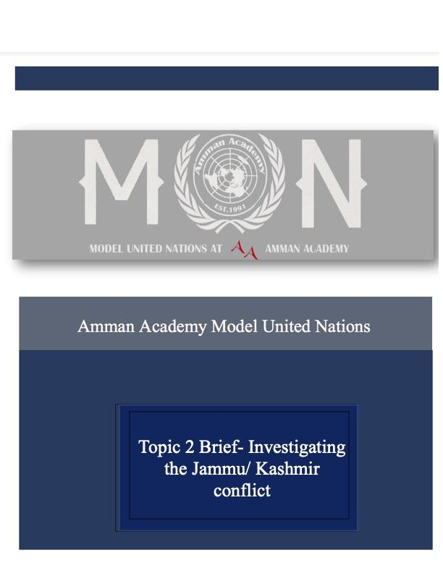

Commission on the Status of Women – Topic 1 Brief

Protection of Women’s Reproduction Rights

**Introduction:**

The Commission on the Status of Women (CSW) is a global intergovernmental body whose sole purpose is to promote gender equality and the empowerment of women. Established by her ECOSOC Resolution 11(II) of 21 June 1946 as a functional commission of the Economic and Social Council (ECOSOC).

CSW helps advance women's rights by documenting the realities of women's lives around the world and shaping global standards for gender equality and women's empowerment.

Reproductive rights are an integral part of women's rights, a fact affirmed by international treaties and enshrined in law in various parts of the world. To be able to exercise their human rights and make important decisions, women must have free and responsible control over the number of their children and access to information, education and services. Violations of women's sexual and reproductive health and rights often result from deeply held beliefs and societal values ​​related to women's sexuality. Women are often judged by their fertility, and blamed for their infertility, suffer from ostracism, and are subject to various human rights violations as a result. Women's ability to control what happens to their bodies is also related to the roles women can play in society, such as family, workers, and government. Early marriage and pregnancy, or repeated pregnancies, often have devastating and sometimes fatal consequences on a woman's health.

**Definition of Key Terms:**

* Reproductive rights/ reproductive health:

Reproductive rights include the rights of all individuals and couples to decide freely and responsibly the number, spacing and timing of their children, and to have the information and means to do so. Further, decisions concerning reproduction should be made free from discrimination, coercion and violence. These services are essential for all people, married and unmarried, including adolescents and youth. For people to realize their reproductive rights, they need access to reproductive and sexual health care in the context of primary health care. This should include a range of family planning; obstetrical and gynecological care; prevention, care and treatment of STIs and HIV/AIDs; education and counselling on human sexuality and reproductive health; prevention and surveillance of violence against women and elimination of traditional harmful practices.

* Sexual and reproductive health and rights (SRHR):

Sexual and reproductive health are essential components of everyone's right to enjoy the highest suitable physical and mental health. Many barriers stand in the way of people enjoying their sexual and reproductive health. These impediments are interconnected and entrenched, operating at various levels: clinical care, health systems, and the underlying determinants of health. In addition to biological factors, a woman's sexual and reproductive health is influenced by social, economic, and other factors.

**General Overview:**

As of recently the overturning of Roe v Wade has brought major attention to women’s rights in general. According to the World Health Organization, between 14,000 and 39,000 mothers die each year because safe abortions are not possible. - Access to contraceptives, safe abortion services and quality post-abortion care, aimed at, inter alia, ensuring universal access to sexual and reproductive health rights and reducing maternal mortality. In the midst of a severe global backlash against gender equality, religion and culture must not be used to discriminate against and oppress women. Such access should be permitted in both normal and humane circumstances.

**Parties Involved:**

* The United States:

The Roe v. Wade decision by the U.S. Supreme Court in 1973 acknowledged that it is the individual's choice, not the government's, to decide whether to prolong or end a pregnancy. The right to an abortion before fetal viability is covered by the particular "liberty" clause in the Fourteenth Amendment of the United States Constitution, which protects individual privacy. Since Roe, the Supreme Court has consistently emphasized that the Constitution protects abortion as an essential liberty, which is connected to other liberty rights to make independent choices about one's family, relationships, and bodily autonomy. However, in 2022, Roe v. Wade was overturned, the decision overturned the long-standing constitutional right to abortion and abolished federal abortion access standards established by earlier decisions in the cases of Roe v. Wade and Planned Parenthood v. Casey. In Dobbs v. Jackson Women's Health Organization, the Supreme Court removed a basic right for the first time ever, reversing over 50 years of precedent. Due to the variation in abortion availability by state as a result of the Roe v. Wade decision, women of color will likely face disproportionate barriers to accessing abortions. Women of color face more barriers to accessing health care in general and have less access to abortion coverage. The international trend is to loosen rather than tighten abortion restrictions. Even countries like Ireland, which has strong ties to organized religion, have legalized abortion in recent years.

* Egypt:

Records of abortion in Egypt date back to the ancient pharaohs, and it is possible that Egyptian methods of abortion were used throughout medieval Europe. Today, however, Egyptian law forbids abortion unless it saves the life of a pregnant woman. Like many countries once under European colonial rule, Egypt's laws derive from its colonizers (in this case 1937 France).

* United Arab Emirates:

According to the UAE law, it is a crime to abort a pregnancy unless it endangers the woman's life or there is evidence that the baby will be born with fatal deformities and will not survive. In the latter case, the fetus must be aborted before it is 120 days old, which is during the 17th week of the pregnancy and one week into the second trimester. The abortion must be approved by an authorized medical board. Abortion of fetus after 120 days of pregnancy is not permitted.

* Iran:

Iran's ban on abortion has forced women to go to underground, often unsanitary facilities to terminate pregnancies. Unhygienic abortion kills many women and can cause lifelong complications. In cases where the pregnant woman's life is in danger or there are abnormalities in the fetus, the new law places the final decision-making authority for therapeutic abortion in the hands of a panel composed of a judge, medical doctor, and forensic doctor, as opposed to the pregnant women with the support of the medical doctor.

* Brazil:

A woman may only get an abortion under Brazil's legal system if it will save her life or if the pregnancy is the consequence of rape or incest. The number of health centers and hospitals where women who meet the requirements of the penal code can obtain abortions has grown during the past ten years in Brazil's healthcare system. Nevertheless, only a small minority of women actually undergo such non-punishable abortions because, historically, medical professionals have typically needed a court order to do the procedure. In fact, the vast majority of abortions in Brazil are carried out in illegal clinics or other hidden locations under questionable medical conditions.

* India:

According to the Supreme Court of India, all women, including unmarried ones, are permitted to have an abortion up to 24 weeks. The court's decision followed a request for clarification regarding the 2021 abortion law amendment, which identified many groups but did not include single women among them. The court ruled that every woman has the right to a safe and legal abortion, regardless of her marital status. India has had a severely skewed gender ratio despite the fact that abortions have been legal there since 1971. As a result of the millions of female fetuses that have been aborted over the years, the government has put strict restrictions on who is allowed to terminate a pregnancy. A variety of categories of women are now permitted to undergo abortions between 20 and 24 weeks after the government modified the Medical Termination of Pregnancy Act (MTP) last year. The list contained pregnant married women whose marital status had changed during the pregnancy, minors, women with mental disabilities, women carrying seriously abnormal fetuses, and rape survivors.

* Costa Rica:

Only when the pregnant woman's life or health is in danger is abortion legal in Costa Rica, but there aren't any rules in place to carry out the law. As a result, access to legal abortion services in Costa Rica is at the doctor's discretion, and frequently, doctors will not even perform legal abortions out of concern for their professional reputation. Currently, if convicted of performing an abortion that was prohibited by Costa Rica's penal code, doctors face sentences of up to 10 years.

**UN Involvement:**

Reproductive rights are integral to women’s rights, a fact that is upheld by international agreements and reflected in law in different parts of the world. The ability of women to control what happens to their own bodies is also associated with the roles women are able to play in society, whether as a member of the family, the workforce, or government. UN Women remains steadfast in our determination to ensure that the rights of women and girls are fully observed and enjoyed worldwide, and we look forward to continued evidence-based engagement with our partners everywhere in support of rapid progress towards universal enjoyment of universal rights. (unwomen.org)

**Possible Solutions:**

1. Maintain and expand access to abortion care through proactive policies and legislation
2. Improve access to contraception by expanding coverage and delivery models and offering additional types of contraception
3. Financial Protection for Family Planning Services

**Bibliography**

<https://www.americanprogress.org/article/13-ways-states-can-protect-advance-womens-health-rights/>

[https://reproductiverights.org/maps/worlds-abortion-laws/?category[1348]=1348](https://reproductiverights.org/maps/worlds-abortion-laws/?category%5b1348%5d=1348)

<https://www.ohchr.org/en/statements/2022/09/womens-and-girls-reproductive-choices-must-be-respected-un-experts-say-0>

<https://www.ohchr.org/en/women/sexual-and-reproductive-health-and-rights>

<https://www.unwomen.org/en/csw>

<https://www.unwomen.org/en/news-stories/statement/2022/06/statement-reproductive-rights-are-womens-rights-and-human-rights#:~:text=Statement%3A%20Reproductive%20rights%20are%20women%27s%20rights%20and%20human%20rights,-Page%20navigation%20Page&text=To%20be%20able%20to%20exercise,information%2C%20education%2C%20and%20services>

<https://www.unicef.org/rosa/media/1761/file/Gender>

<https://www.hrw.org/legacy/women/abortion/brazil.html>

<https://news.un.org/en/story/2021/11/1105922>

<https://www.bbc.com/news/world-asia-india-63071113>

<https://reproductiverights.org/roe-v-wade/>

<https://reproductiverights.org/despite-countrys-own-laws-costa-rica-continues-to-deny-women-legal-abortion/>